Name: kip taylor

CS 33007 Introduction to Database System Design, Spring 2021
Final Exam
Instructions:
- If needed you can use pen and paper. Do not forget to take a snapshot of the paper and attached to the answer script.
- You must submit your answer script at Blackboard (Pdf format Preferable).

Total Points: 50 Time: 12:45-2:00PM
Section 01: 20 Points(10+10)
Normalize the following table up to 2nf
Ref No | Name | Address | Status | AccNo
345 | C.J Date | 23, High Street | Business | 120768, 348973
543 | F.D Rolland | 45, The Ash | Domestic | 987645
675 | D.R Howe | 17, Low Street | Business | 745363, 678453, 348973

1 nf conversion:
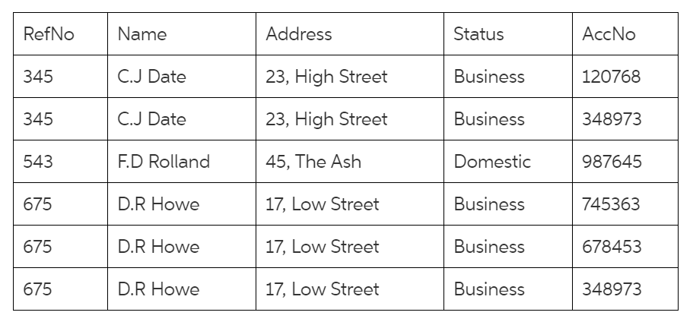
2nf conversion from normalized form : 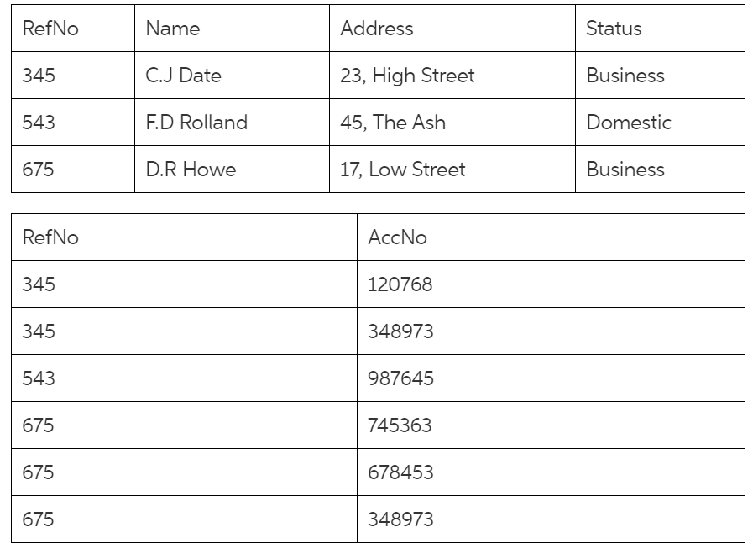
This should be correct, thank you.
Section 02: 20 Points(10+10)
Suppose you need a covering index to support a query.
- Write a query and create a covering index and show your result.
- Answer must include the instruction for creating the covering index and index table.
Customer  ID | Customer  Name | Contact  Name | Address | City | Postal  Code | Country
1 | Alfreds Futterkiste | Maria Anders | Obere Str. 57 | Berlin | 12209 | Germany
2 | Ana Trujillo Emparedados y helados | Ana Trujillo | Avda. de la Constitución 2222 | México D.F. | 05021 | Mexico
3 | Antonio Moreno Taquería | Antonio Moreno | Mataderos 2312 | México D.F. | 05023 | Mexico
4 | Around the Horn | Thomas Hardy | 120 Hanover Sq. | London | WA1 1DP | UK
5 | Berglunds snabbköp | Christina Berglund | Berguvsvagen 8 | Lulea | S-958 22 | Sweden

A: table below
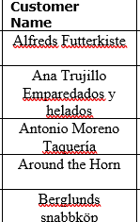 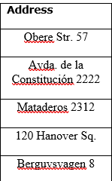 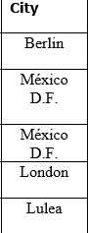 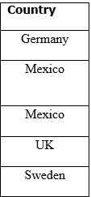 this is all one table.
B. Here is the instructions: Create index idx_customer on customer(contact name, address, city, country)
Section 03: 10 Points(08+02)
Draw the Relational algebra expressions and query-evaluation plans for the following query. Mark the most efficient query-evaluation plan between your plans.
Find the names of all instructors in the Physics department, along with the titles of the courses that they teach

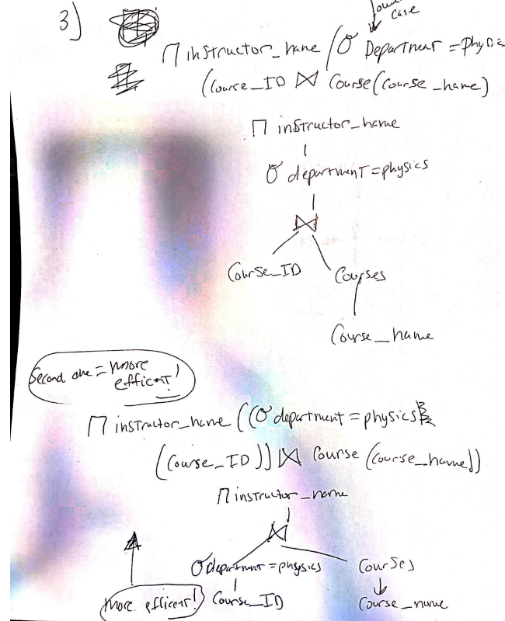

this should cover the question and second one is more efficient.

Section 04: 10 Points(07+03)
- Suppose you have to recommend a technology for a new database to keep the BMV (Bureau of Motor Vehicles) record the state of X (Approx. record 100,000). You can use whatever database technology you want (Relational/NOSQL). Share you your recommendation about a choice of technology and your reasoning behind the recommendation.
Answer: I’d recommend using NOSQL because it’s a document-oriented database. I feel like this type of database technology would work better for the keeping track of the BMV’s records for x State. It also would allow the user to be more in control of the structure of the data and allows for a good use of databases in the agile development.
- Why is the CAP theorem important?
Answer: cap theorem is important due to its three characteristics: availability , partition tolerance and consistency. Of the three the two most important are availability and partition tolerance, since even if the case of network fault , the distributed system can still function , along with successful handling of requests with reading or write operations , and then displaying if that can or cannot be performed.

